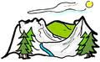
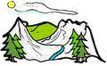
GORSKI KRAJEVI RH
ispit znanja
IME I PREZIME: ..................................................................... NADNEVAK:............................
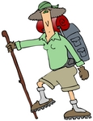
BOD./OCJ.:............................................................................ POTPIS RODITELJA:...................................................
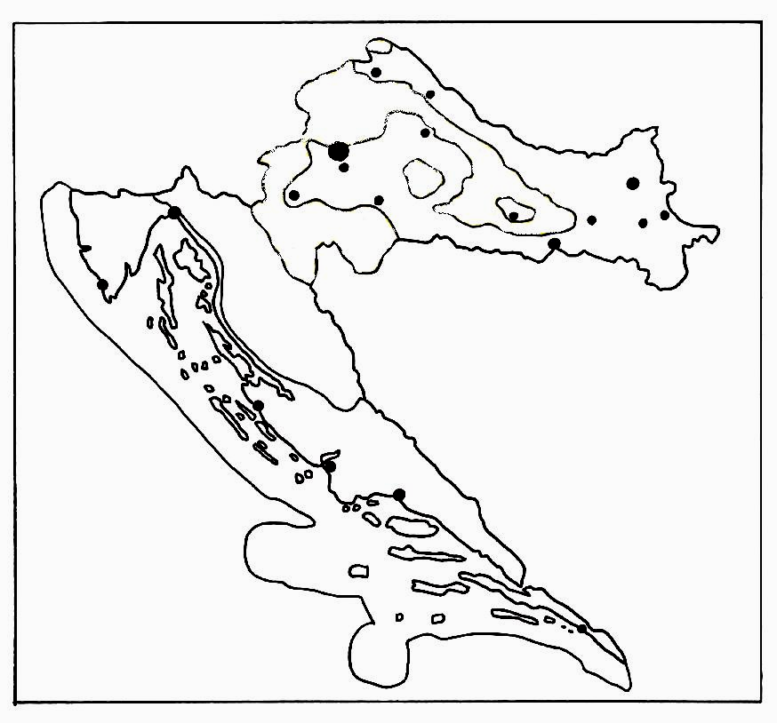
- Na zemljovidu smeđom bojom oboji
gorski kraj Republike Hrvatske.

- Strjelicom označi dva zavičajna područja gorskih krajeva.

- Nabroji nekoliko uzvisina(gora, planina) gorskog kraja.
.......................................................................
.......................................................................
.......................................................................

- Nabroji neke rijeke gorskog kraja.
.......................................................................
.......................................................................
.......................................................................

- Opiši svojim riječima kakvo je podneblje gorskog kraja RH. ........................................................................................................................................................................................
.........................................................................................................................................................................................
.........................................................................................................................................................................................

- Koje smo gospodarske djelatnosti gorskoga kraja naveli kao bitne?
.........................................................................................................................................................................................
.........................................................................................................................................................................................

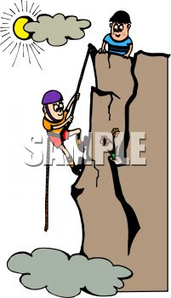
- Što privlači turiste u gorske krajeve? Objasni što se sve može vidjeti i posjetiti.
............... .......................................................................................................................................................................
............... ......................................................................................................................................................................
............... ......................................................................................................................................................................
.........................................................................................................................................................................................

- Gdje su se u gorskom kraju smjestila sela?.....................................................................................................................

- Zašto je tako mala naseljenost i veliki broj iseljenika iz gorskog kraja?
.........................................................................................................................................................................................

.........................................................................................................................................................................................

- Nabroji neke gradove gorskih krajeva. Ako znaš, napiši što je za njih bitno reći.
.........................................................................................................................................................................................
.........................................................................................................................................................................................

- Ispuni mapu odgovarajućim podatcima.

